We have great news! Your iSolved Mobile app is about to get a whole lot better. The new app is called iSolved GO and it has a brand new look and feel along with improved functionality, so you can handle your tasks while on the go.
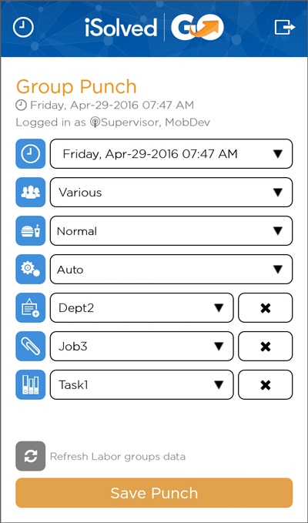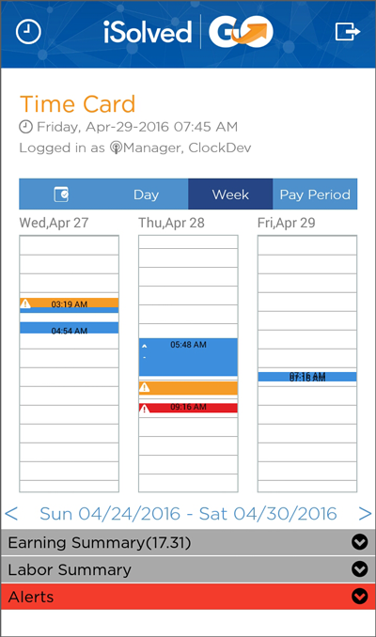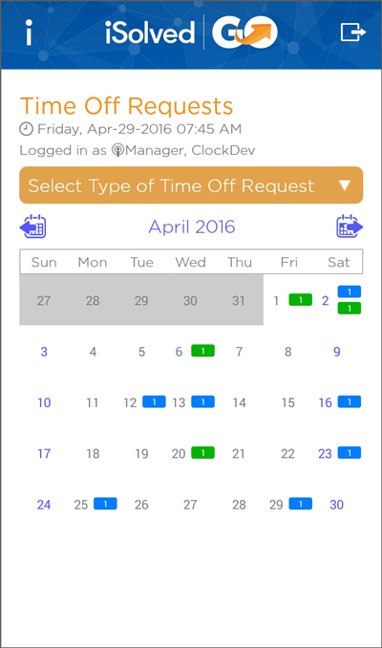

The new app is available in both the Google Play Store and App Store for Android and iOS users. When you sign into the current app, you’ll be prompted to download iSolved GO. Once you have it installed, you’ll be able to take advantage of the many new mobile features available.

Features include:
Time card view: pay period, weekly, day
Remember password feature
Ability to view previous paystubs
Group punch feature
Supervisors can make changes on behalf of their employees (tax withholdings, update information, view paystub)

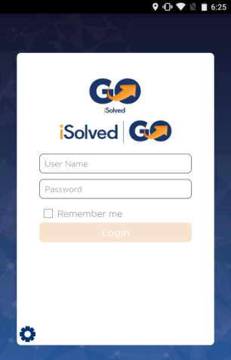
But don't worry — all of the features and functions from the previous app will be there too. And we’ve even added the ability to provide feedback right from the app! No need to go back to the app store.

How do I get started with the new app?

1 | Your current app will prompt you to download the new version. Simply follow the link to the appropriate app store and install it.
2 | When you login to the new app for the first time you will need to enter some information, one time only. For iSolved GO you will first need to enter you Network Partner ID, which is pcspay. To do this, click on the gear icon shown below. Enter the Partner ID on the next screen.
3 | Back on the main login screen, simply enter your Username and password as normal. This information can be saved so that you only have to enter it once.

Get ready for iSolved GO!

